1. Elastic Search忘记密码:

bin/x-pack/users useradd my_admin -p my_password -r superuser

注: my_admin my_password可以自定义

1. **elasticsearch更新license授权文件**
2. **windows环境 https://blog.csdn.net/lvyuan1234/article/details/78647808**

第一步：去elasticsearch官网申请一个新的license，打开申请地址<https://register.elastic.co/marvel_register>

    填入各项信息后，会给你邮箱发送一封license的下载地址，有两个版本2.x和5.x，根据自己的elasticsearch版本选择

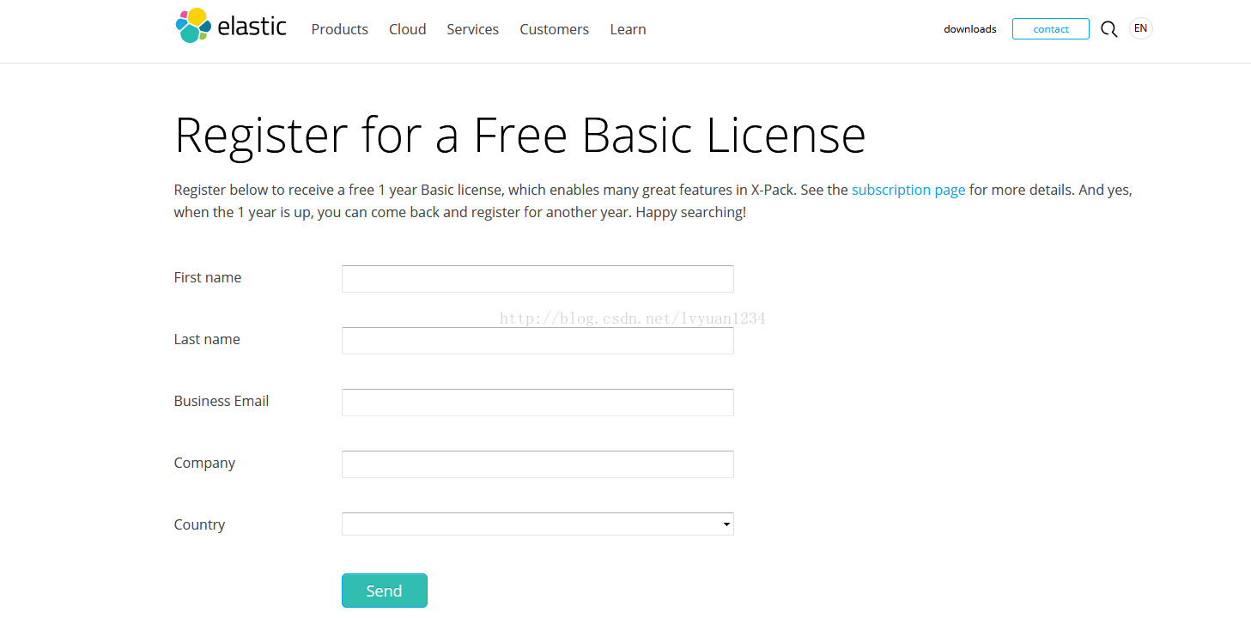

    第二步：打开postman，请求方式为put，填入提交的url地址，在Authorization中填入用户名和密码，先别发送

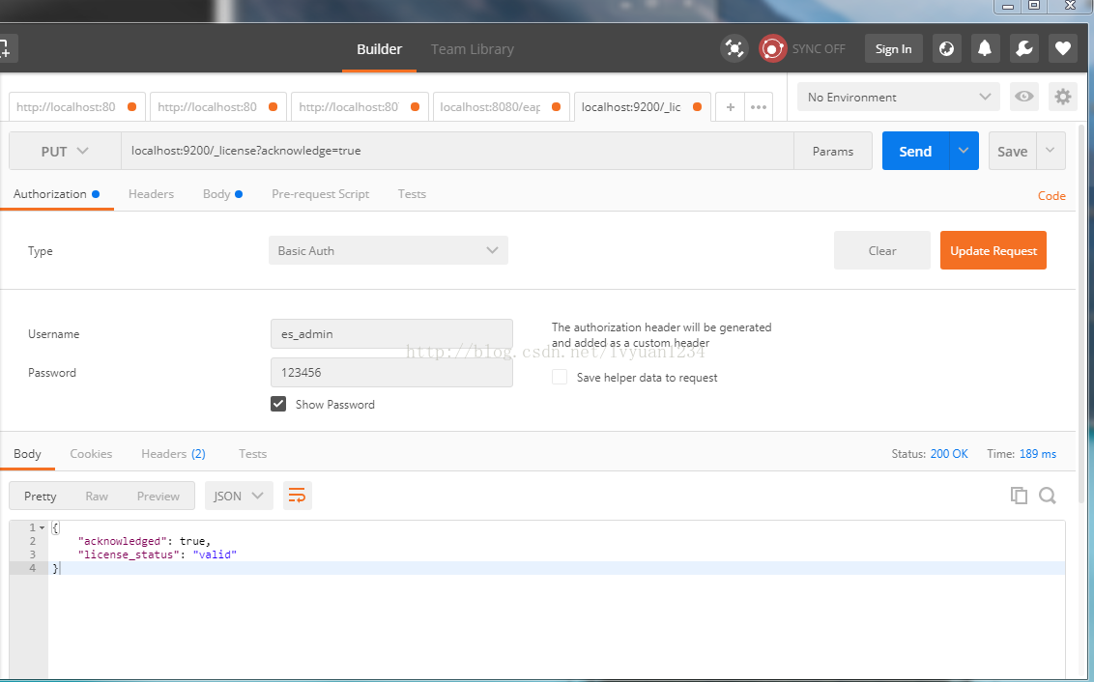

    第三步：在body>raw里面粘贴上你申请的license文件的内容：

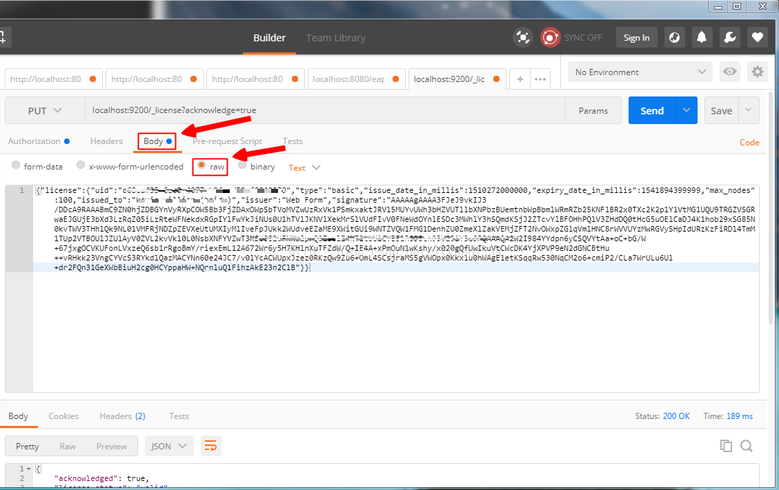

     第四步：点击send按钮发送就更新成功了。然后再启动elasticsearch就ok了

1. Linux 环境 https://www.cnblogs.com/kasumi/p/6419803.html

1.curl -XPUT ‘<http://10.26.44.42:9200/_license>’ -d @license.json  
返回：  
{"acknowledged":false,"license_status":"valid","acknowledge":{"message":"This license update requires acknowledgement. To acknowledge the license, please read the following messages and update the license again, this time with the "acknowledge=true" parameter:","marvel":["basic","Automatic index cleanup is locked to 7 days for clusters with [{}] license.basic"]}}

2.curl -XPUT ‘<http://10.26.44.42:9200/_licenses?acknowledge=true>’ -d @license.json  
返回：  
{"acknowledged":true,"license_status":"valid"}

3.curl -XGET -u user:password ‘<http://10.26.44.42:9200/_license>’  
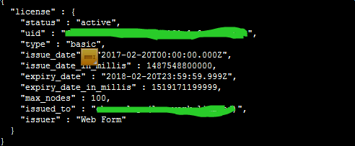

参考文档：  
Elasticsearch2.x:  
<https://www.elastic.co/guide/en/marvel/current/license-management.html>  
Elasticsearch5.x:  
<https://www.elastic.co/guide/en/x-pack/current/installing-license.html>